Kevin Chen

8/12/18

Knowledge-Based AI Notes

**Intro to Knowledge Based AI**

Conundrums in AI

* Intelligent agents have limited computational resources. Most interesting AI problems are computationally intractable.
* Computation is local, but problems have global constraints
* Logic is deductive, but many problems are abductive or inductive.
* The world is dynamic, but knowledge is limited. How can an AI agent address a new problem?
* Problem solving, reasoning, and learning are complex, but explanation and justification are even more complex. How can we get an AI agent to explain/justify its decisions?

Characteristics of AI Problems

* Knowledge often arrives incrementally.
* Problems exhibit recurring patterns
* Problems have multiple levels of granularity/abstraction.
* Many problems are computationally intractable.
* The world is dynamic, but knowledge of the world is static.
* The world is open-ended, but knowledge is limited.

Characteristics of AI Agents

* Agents have limited computing power.
* Agents have limited sensors.
* Agents have limited attention. (Cannot focus on everything on the same time)
* Computational logic is fundamentally deductive.
* AI agents’ knowledge is incomplete relative to the world.
* How can AI agents with such bounded rationality address open-ended problems in the world?

Example: Watson (Jeopardy AI)

* Watson must be able to read the clue, then search through its knowledge base, decide on its answer, and then phrase its answer in the form of a question.

What is Knowledge-Based AI?

* Consists of knowledge representations, problem solving technique, and architectures.
* Reasoning, learning, and memory are the fundamental processes of knowledge based data.
* They are all interconnected. Example, what you learn must be stored in memory. When reasoning, you need to retrieve what you know from memory.
* The 3 processes put together is called deliberation. The deliberation process is one part of the overall architecture of a knowledge based AI agent.

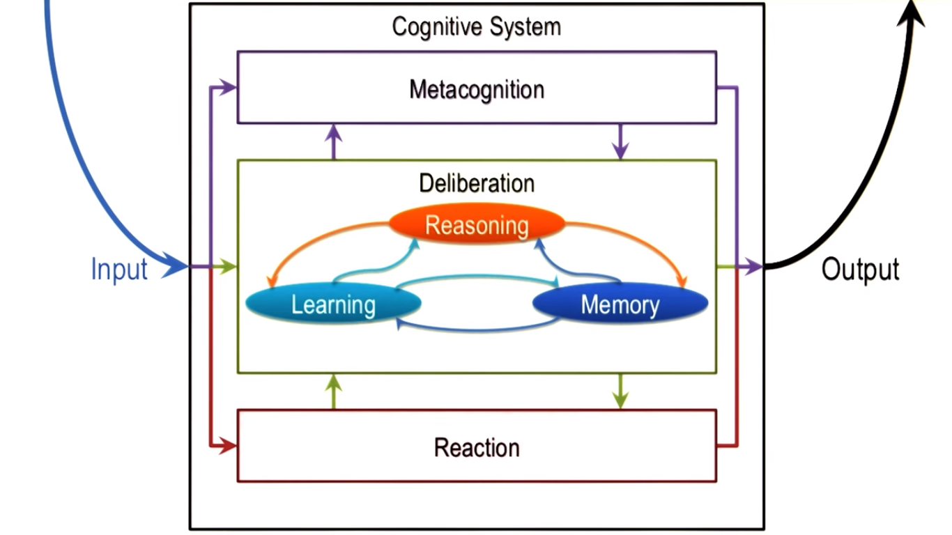

Foundations: The Four Schools of AI

* One spectrum of thinking vs acting. Another spectrum is thinking optimally vs. acting and thinking like humans.
  + Humans are not optimal but good for general tasks. In contrast, AI agents may be optimal for one specific task.
* In Knowledge-based AI, we are focusing on agents that think like humans.
* Examples:
  + Thinking optimally: machine learning, route navigation
  + Acting optimally: airplane autopilot, autonomous driving vehicles, Roomba
  + Thinking like humans: semantic web, Siri (Apple virtual assistant)
  + Acting like humans: improvisational robots, C-3PO (Star Wars)

What are Cognitive Systems?

* Cognitive: dealing with human-like intelligence.
* Systems: multiple interacting components such as learning, reasoning, and memory.
* Cognitive Systems: systems that exhibit human-like intelligence through processes, like learning, reasoning, and memory.

Cognitive System Architecture

* Note that the term knowledge-based AI is not necessarily describing a system that is human-like.
* Cognitive systems are situated in the world. It has percepts (things that can be perceived/sensed)
* The cognitive systems uses sensors to perceive the percepts. That is the input of the cognitive system.
* The cognitive system has actuators to carry out actions on the world. Actions are the output.
* One can have multiple cognitive systems that interact with each other and the world.
* (Refer to cognitive system diagram above)
* A cognitive system maps sensor inputs to actions.
  + One way to map inputs to actions is through reactions. This is a direct mapping.
  + Deliberation is another mapping (refer above)
  + Metacognition reasons about deliberation or about reaction. Helps with learning. Does not map input to output.
* Intelligence is about mapping percepts in the world into actions in the world.
  + It is about selecting the right kind of action given a particular state of the world.
* This is called the three-layer architecture.

Topics in Knowledge-Based AI

* Fundamentals: knowledge representation and reasoning strategies. 2 main representations are semantic networks and production systems. Three main reasoning strategies are “generate and test”, “means-end analysis”, and “problem reduction”
* Planning: logic as a knowledge representation, and planning
* Common Sense Reasoning: reasoning about everyday situations in the world. Frames is a knowledge representation, and the methods for common sense reasoning are “understanding”, “common sense reasoning”, and “scripts”
* Analogical Reasoning: reasoning about novel problems/situations but analogic to what we know about familiar problems. Learning by recording cases, case-based reasoning, explanation-based learning, and analogical reasoning.
* Metacognition: thinking about thinking. Learning by correcting mistakes, meta-reasoning, and ethics in AI
* Design & Creativity: dealing with novel situations. Configuration, diagnosis, design, and creativity
* Visuospatial Reasoning: reasoning with visual knowledge. Constraint propagation to do visuospatial reasoning
* Learning: learning by recording cases, incremental concept learning, classification, and version spaces

**Introduction to CS7637**

Introduction to Computational Psychometrics

* Psychometrics is a study of human intelligence/knowledge/aptitude.
* Computational psychometrics is the design of computational agents that can take the same tests as humans do when they are tested or intelligence.
* We will be designing agents that can take the Raven’s Test of Intelligence.

Raven’s Progressive Matrices

* Test written in the 1930s to examine general intelligence
* Consist of 60 multiple-choice visual analogy
* Unique in that problems are strictly visual (no words)
* Widespread usage as a valid test for intelligence
* Two kinds of problems:
  + 2 x 2 matrix problems and 3 x 3 matrix problems
  + We will consider 2 x 1 matrix problems but those are not part of the original test.

Example of Raven’s Progressive Matrix (2 x 1):

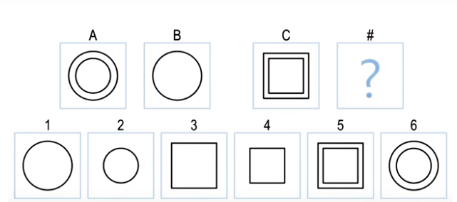

Correct Answer: 3

Example of Raven’s Progressive Matrix (2 x 2):

* There are two relationships: A maps to B as C maps to D AND A maps to C as B maps to D.
* You may want to enforce diagonal relationships as well: B maps to C as A maps to D.

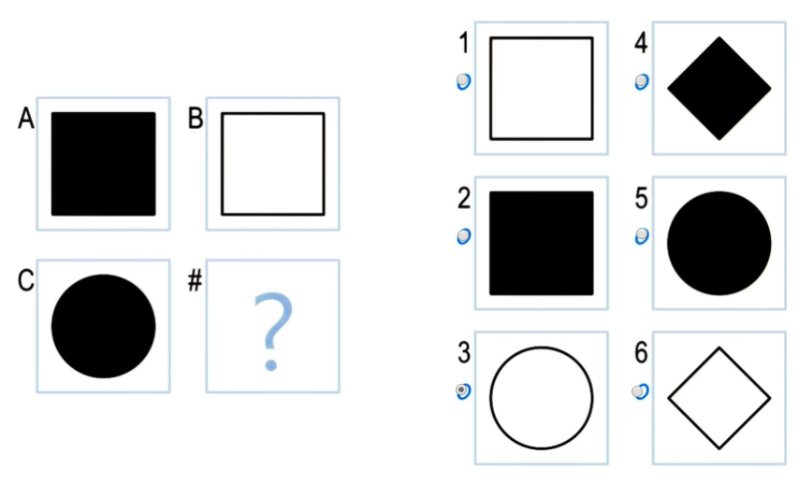

Correct answer: 3

Principles of CS 7637

1. KBAI agents represent and organize knowledge into knowledge structures to guide and support reasoning.
2. Learning in KBAI agents is often incremental.
3. Reasoning in KBAI agents is top-down as well as bottom-up. We don’t just reason from data. we use data to pull out knowledge from memory to generate expectations to make sense of the world.
4. KBAI agents match methods to tasks (i.e. select methods to address particular tasks)
5. KBAI agents use heuristics to find solutions that are good enough, though not necessarily optimal.
6. KBAI agent make use of recurring patterns in the problems they solve.
7. The architecture of KBAI agents enables reasoning, learning, and memory to support and constrain each other.

**Semantic Networks**

Knowledge Representations

* In each knowledge representation, there are two things: a language and content.
  + That language has a vocabulary.
* F = ma is a knowledge representation. Language is equations. Content is the actual equation.

Introduction to Semantic Networks

* First, represent the objects. Then represent the relationships between these objects.
* Next, you want to find the transformation of A -> B.
* Example:

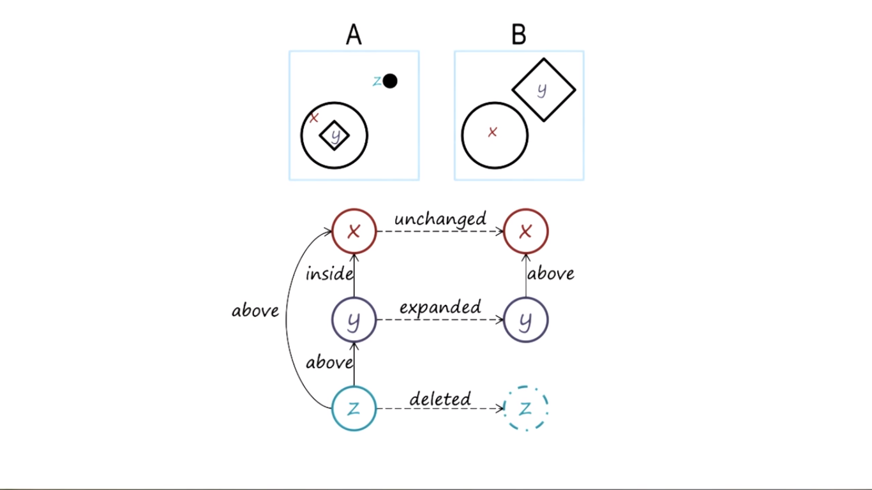

* Be sure to use the same vocabulary when using semantic networks to create analogies.

Structure of Semantic Networks

* Lexicons: vocabulary of the presentation language
* Structure: how the words of the vocabulary can be composed together into complex representations
* Semantics: how the representation allows us to draw inferences

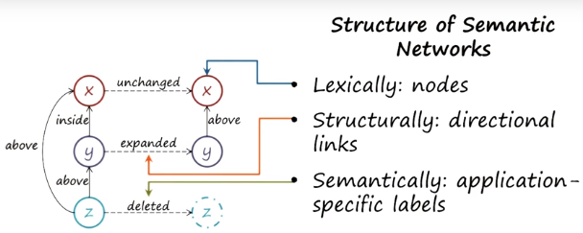

Characteristics of Good Representations

* A good representation:
  + Makes relationships explicit
  + Exposes natural constraints
  + Brings objects and relations together
  + Excludes extraneous details
  + Is transparent, concise, complete, fast, and computable

Guards and Prisoners

* Aka cannibals and missionaries, jealous husbands, brothers and sisters
* Three guards and three prisoners must cross river. Boat may take only one or two people at a time. Prisoners may never outnumber guards on either coast, though prisoners may be alone on either coast.

Semantic Networks for Guards & Prisoners

* Each node is a particular state in the problem.
* Links are shown as transitions from one state to another.

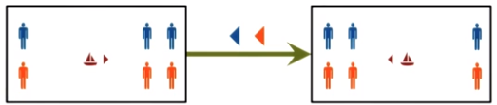

Solving the Guards and Prisoners Problem

* Simple way is to rule out any illegal moves, and any moves that are obviously not productive.

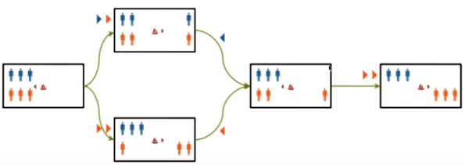

Represent & Reason for Analogy Problems

* The following Analogy problem shows why choice “5” might not be the best solution (as there is one link that is different):

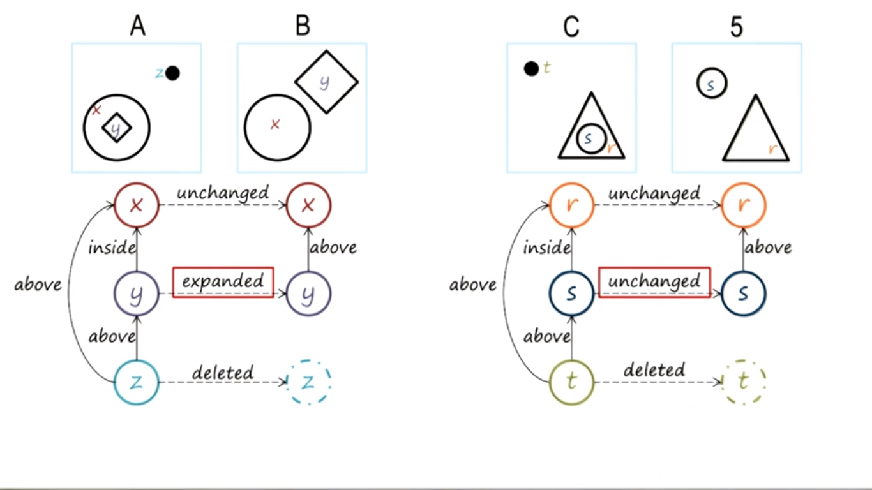

* This is a better solution:

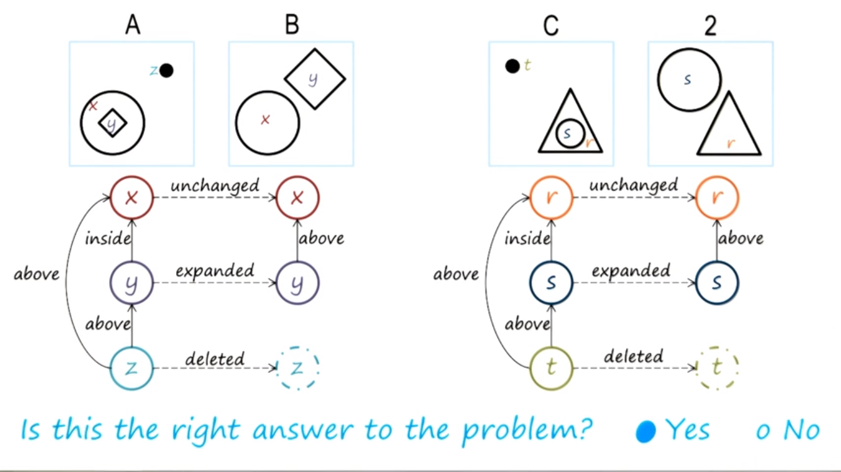

* If we didn’t have an exact match, then we might find a way to evaluate how similar the matches are (e.g. 95% similar)

Choosing Matches by Weights

* Sometimes, there may be multiple answers that may be correct. Example:
  + Choice 5 (omitting the inner shape) is often chosen, but Choice 3 (expanding the inner shape and omitting the outer shape) may also be correct.

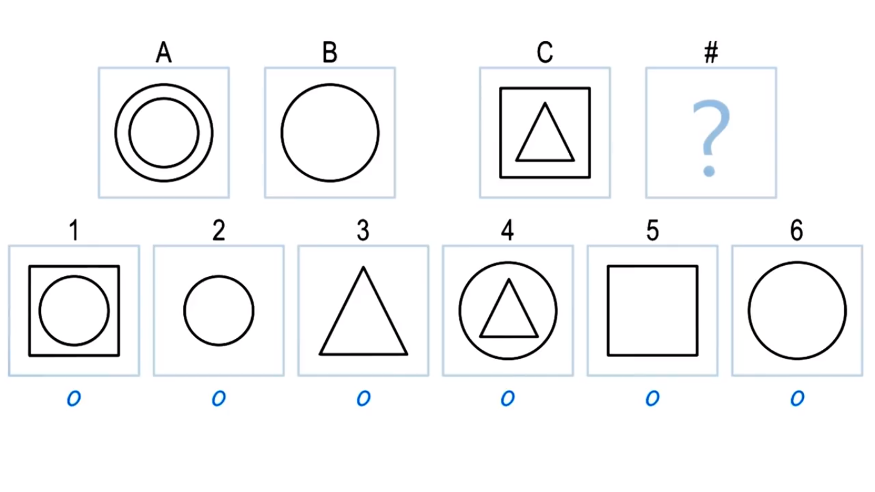

* An AI solving this problem could use weights to see which transformation is the simplest.
  + Higher value = easier transformation. Lower value = big transformation, less similarity
  + Now the AI would prefer answer 5 instead of answer 3, using transformation #1.

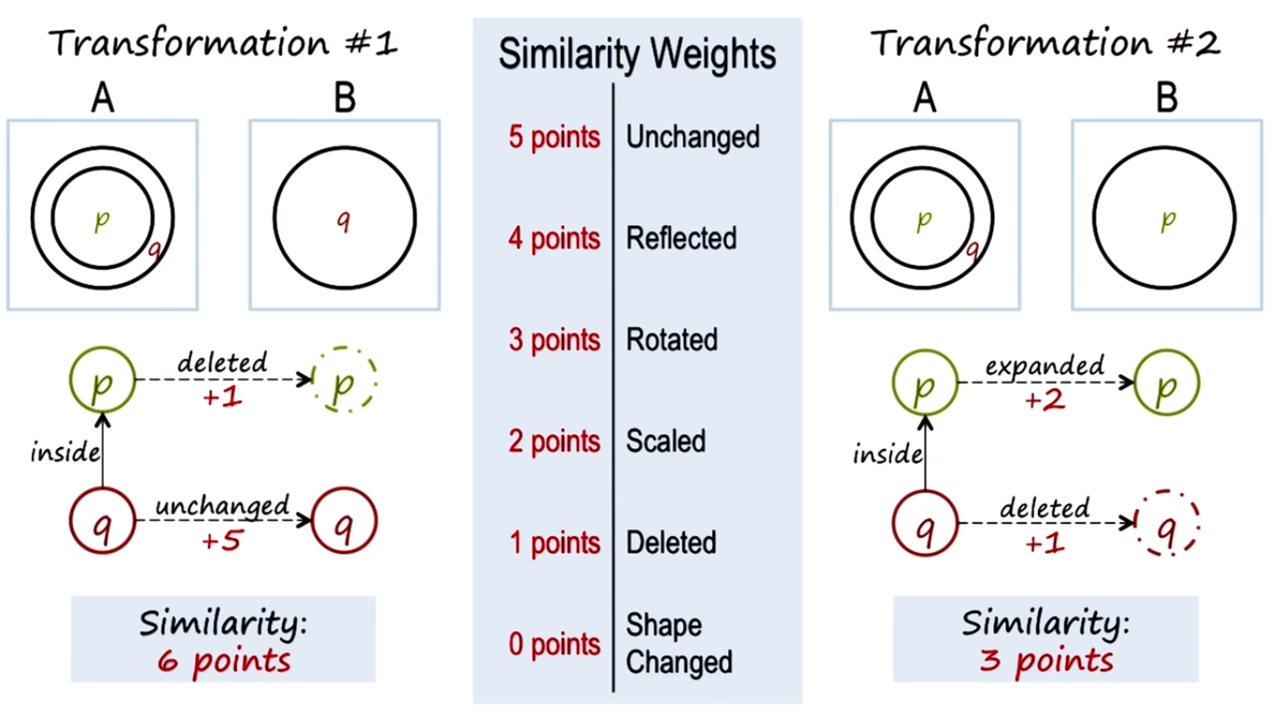

Connections

* Memory: A & B are stored into memory. C & D are probes into memory, and the question becomes which of these probes is most similar to what’s stored in memory
* Reasoning: (look at above example) Correspondence problem -> Should we make connection between outer circle to B, or inner circle to B?
* Cognition: relationships between objects (e.g. triangle inside square),

The Cognitive Connection (Similarities between Human Cognition and Semantic Networks)

* Semantic networks are a kind of knowledge representation to represent both knowledge and the problem. Similarly, the human mind represents problems and knowledge and uses the knowledge to solve the problem.
* Semantic networks are related to spreading activation networks: imagine a large graph of nodes. You are given a few pieces of information with trigger the respective paths of the graph. Eventually, once you are given enough information, the paths of the graph merge for you to draw conclusions on your own.

**Generate and Test**

Preview

* Generate and Test is a problem solving method.
* Given a problem, generate potential solutions, and test the solutions for the efficacy for addressing the problem.
* If you had complete and correct knowledge of the world, infinite computational resources, and a method of reasoning that would be guaranteed to be correct, you could generate the correct, optimal solution. But since often this isn’t the case, you would want to test your potential solutions.

Guards and Prisoners

* Imagine a generator that generates all possible successive states. This is a dumb generator, so we need a tester to prune out useless states.
* Imagine that the tester is also dumb (only removes states that are illegal).
* We eventually get a lot of states if we have dumb generators and testers, even though we started from just one state. This is called combinatorial explosion. This is computationally inefficient. We need a smarter generator and smarter tester.

Smart Testers

* A smarter test could detect when any state is identical to a previous state.
* A knowledge representation alone is not enough to solve a problem. You must also have a problem solving method (e.g. generate and test)

Smarter Generators

* We could make the generator smarter by not generating states that are identical to a previous state. And/or possibly make the generator not generate illegal states.
* Generate and Test is widely used, but often inefficient because the generator and/or tester are usually not that smart.
* Another improvement for the generator/tester would be to avoid sending one person over to an empty coast.

Generate & Test for Raven’s Problems

* Raven’s Problems are more difficult than Prisoners and Guards because there were a finite number of states that could be generated from a particular state. An arbitrarily large number of inferences can be created for each Raven’s Problem.
* Hence, a smarter generator and smarter tester is really needed because the space of possibilities can become very large very quickly.

Semantic Networks for Generate and Test

* The semantic network knowledge representation provides a level of abstraction at which the problem gets represented and analyzed.
  + All we care was that a shape was expanded, for example. We don’t care if it was expanded by 52% of the original size or displaced 5 mm from the edge of the box.
* All knowledge representations pick a level of abstraction to represent the world.
* It is the combination of the knowledge representation and problem solving method that provides reasoning to solve the problem.

Generate & Test for Raven’s Problems

* Two methods:
  + Find the transformation from A -> B, and then generate your answer for D based on C. Then compare it against the answer choices, and try to find another transformation if none of them match.
  + Try each answer choice. For each answer choice, generate the transformation from C -> D and compare it with A -> B. Find which one of these transformations is closest to A -> B.

The Cognitive Connection

* Humans use generate and test all the time because we don’t have complete knowledge of the world, infinite computational resources, and a method of reasoning that is guaranteed to be correct.
* Genetic algorithms in biology use generate and test through operations like crossover and mutation, with solutions that can then be tested against a fitness function.

**Means-Ends Analysis and Problem Reduction**

The Block Problem

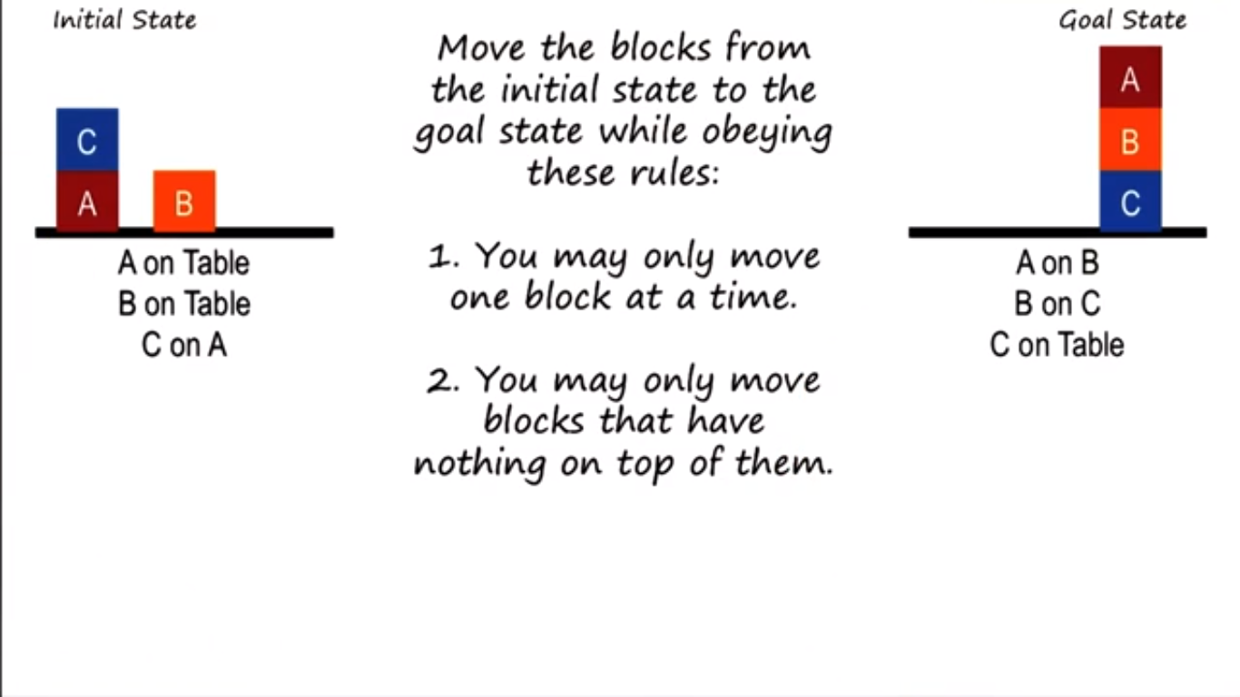

* Available operators: Move(Object, Location)
  + Examples: Move(C, Table) moves C onto table. Move (C, B) moves C onto B.
* Solution: Move(C, Table), Move(B, C), Move(A, B)

State Spaces

* The state space consists of the initial state, goal state, and all possible intermediate states.
* The question is: how can an AI agent derive a path from the initial state to the goal state?

Differences in State Spaces

* You need a function that returns the difference between a particular state and the goal state. Your AI agent could then pick operations that reduce the difference between the current state and goal state.
* The reduction between the difference between the current state and goal state is the ends. The application of the operator is the means. Hence, means-ends analysis.
* Example:

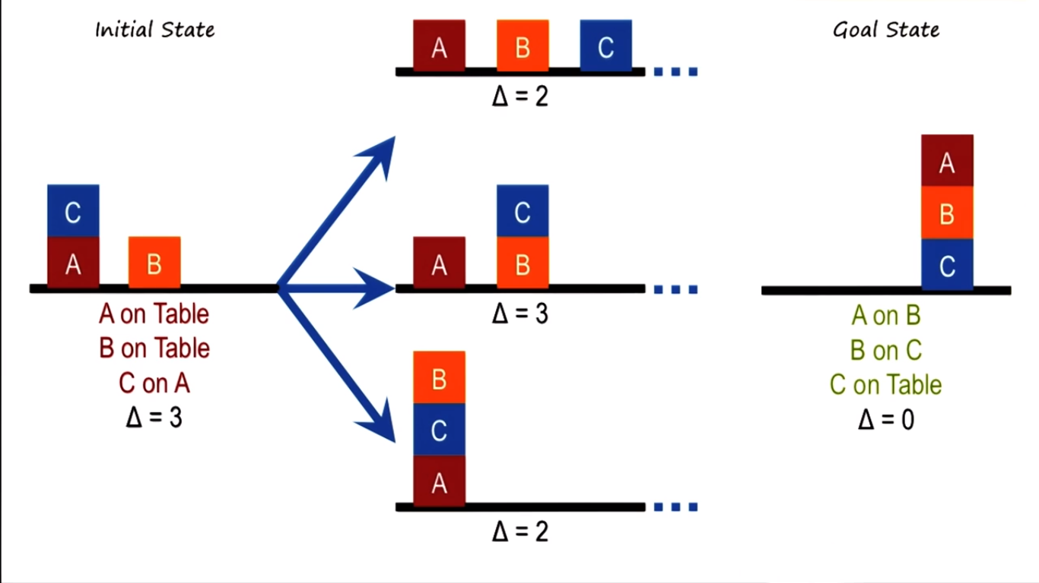

Process of Means End Analysis:

* For each operator that can be applied:
  + Apply the operator to the current state.
  + Calculate the difference between new state and goal state.
* Prefer state that minimizes distance between new state and goal state.
* Sometimes means-ends analysis can take you farther away from the goal (just like how a heuristic in the context of path planning is not perfect)
  + If all operations cause you to increase the difference between the current state and goal, then you need a different approach.
* “Generate and Test” and “means-ends analysis” are applicable to a very large class of problem, but they come with few guarantees of success, are very costly, and does not provide any guarantee of the optimality of the solution they come up with.

Problem Reduction

* Given a hard problem, decompose it into many smaller, easier problems.
* Then you can think about how to compose the sub-solutions to the sub-problems into a solution of the problem as a whole.

Problem Reduction in the Block Problem

* We have several sub-goals, of which we focus on one at a time. Example:

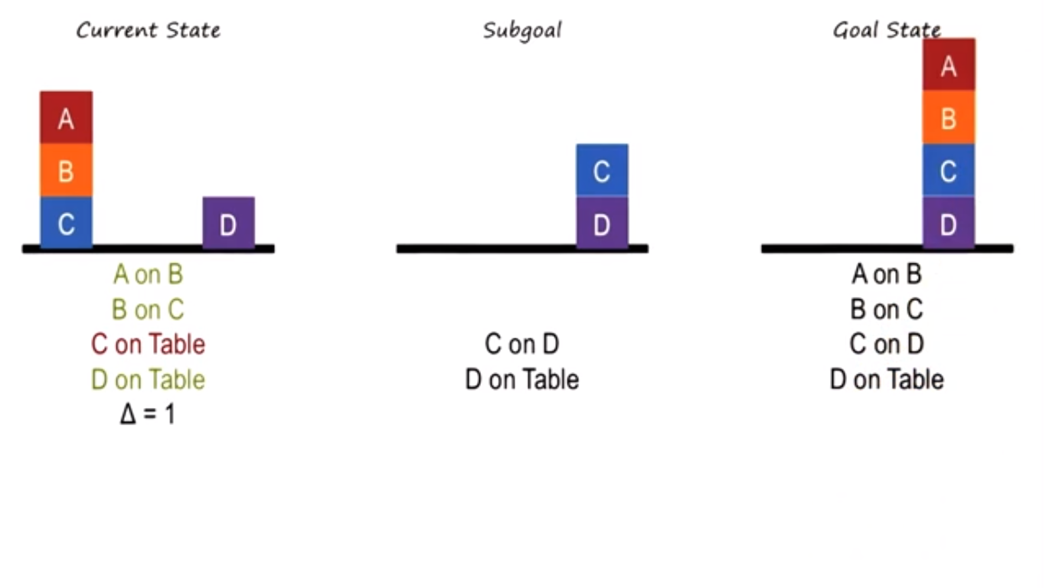

* Now your difference calculations are based on the difference between the current state and subgoal, not current state and goal.
* Problem reduction does not provide guarantees of success.

Means-Ends Analysis for Raven’s

* Can think of transformations as a sequence of basic operations.
  + Then apply those same operations to image C (the one whose analogy you’re trying to figure out).

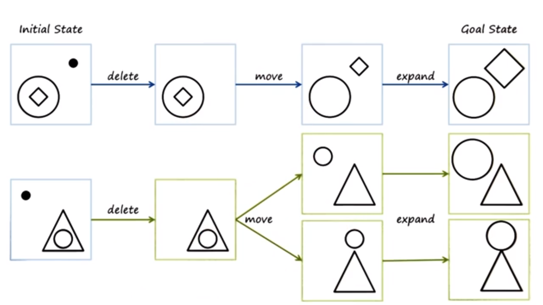

* + But note that we made some assumptions about correspondence. For example, how did we know that the inner diamond corresponds to the inner circle?
  + There is an “inside” relationship that shows that they may correspond.
* This is also like problem reduction: find the series of operations to get the transformation of A -> B. Apply that transformation to C and find some candidate states for D. Then compare those candidates for D to choices in our problem.
* This is also like generate and test: we generate candidate solutions and test them against our choices.
* These are “weak” methods: the coupling between semantic network (knowledge representation) and the three methods are weak.

The Cognitive Connection

* Means ends analysis, problem reduction, and generate and test methods are weak methods b/c they make only little use of knowledge. Knowledge intensive methods use a lot of knowledge, but such knowledge might not be available.
* Similarly, humans use knowledge intensive methods when they are an expert in a particular domain. Else, we use weak methods.

**Production Systems**

Function of a Cognitive Architecture

* A cognitive agent is a function that maps the history of percepts into an action
  + f: P* -> A
  + The asterisk (*) meaning the history (of percepts).
* Answers the question: what should we do next?

Levels of Cognitive Architectures

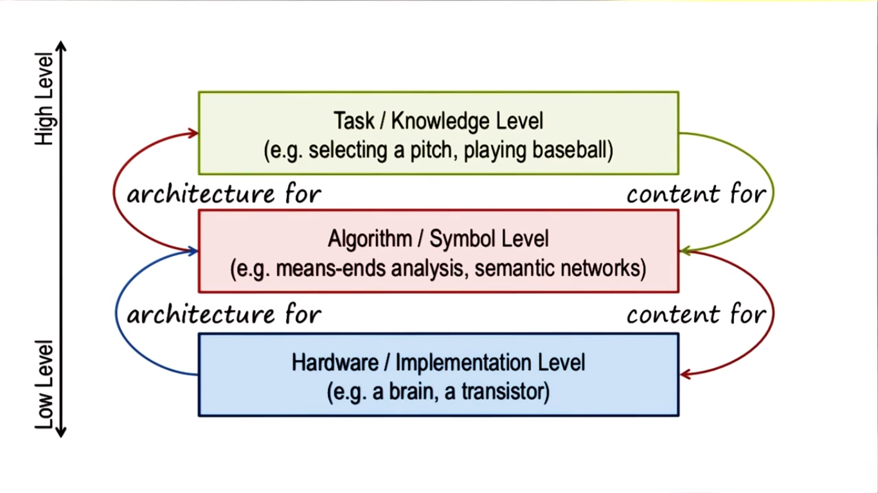

* The lower levels support the upper levels. The upper levels provide information for the lower levels.
* These three layers are useful to show how cognitive systems work, and we want to build theories/constraints based on all three different levels of abstraction.

Example: Levels of Architecture of Watson:

* Hardware: the physical computer
* Algorithm: searching and decision-making
* Task: Answering the inputted clue

Assumptions of Cognitive Architectures

* Assumed that cognitive architectures:
  + Are goal-oriented
  + Live in rich, complex environments
  + Have significant knowledge (of the complex world to pursue their goals)
  + Represent knowledge at a useful abstraction. Knowledge is captured using symbols.
  + Are flexible and a function of the environment (change depending on the environment)
  + Learn from their experiences

Architecture + Content = Behavior

* If you want an intelligence machine that exhibits a particular kind of behavior, you need to design the right kind of architecture, and put the right knowledge content into that architecture.
  + If the architecture is fixed, we can map behavior to content.
* This is similar to computer architecture: stored programs are content, and running the stored programs gives you different behaviors. Architecture doesn’t change.

A Cognitive Architecture for Production Systems

* SOAR is a specific cognitive architecture for deliberation
  + SOAR can also be used to cover certain aspects of metacognition and reaction.

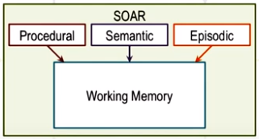

* Consists of long term memory and working memory
  + Long term memory consists of three kinds of knowledge: procedural, semantic, and episodic. Episodic are specific instances of events. Semantic are generalizations/concepts/models. Procedural deals with how to do certain things.

Pitcher Example Problem

* It’s the top of the 7th inning. There are runners on 2nd and 3rd base. There are two outs. The batter, Martin Prado, has an average of .256 and bats fourth in the batting order. We are winning 3-2. I struck this batter out last time. My goal is to escape the inning. What should the pitcher do: pitch to the batter or intentionally walk the batter.
* Some may choose to intentionally walk the batter to get a force out on all bases.

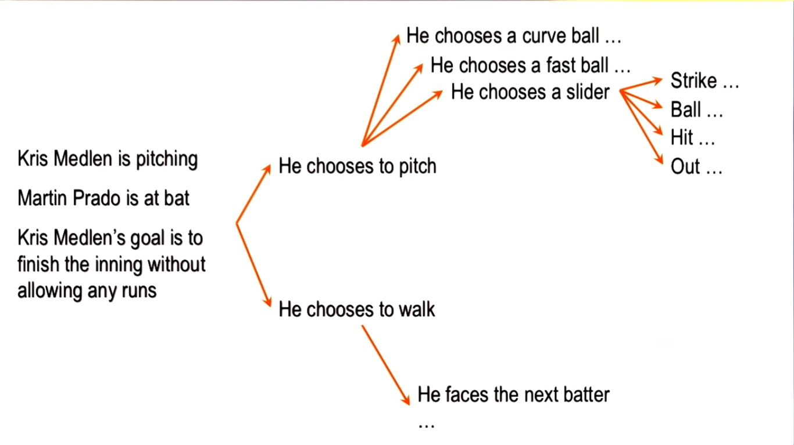

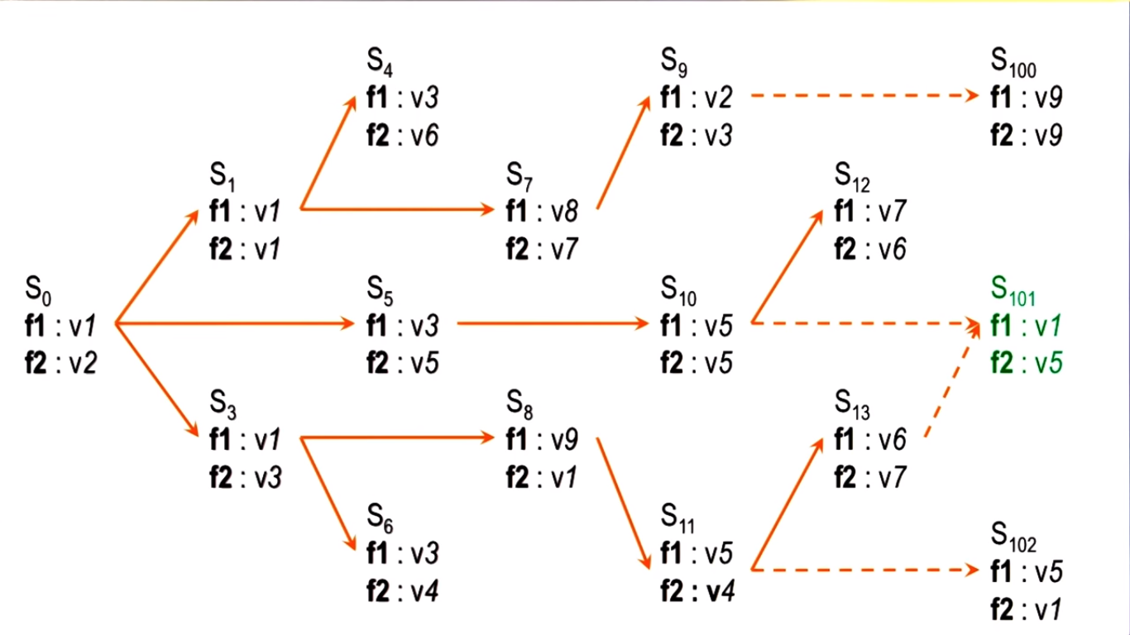

* This is an abstract state space. The pitcher’s decision making is a path from the current (initial) state to the goal state.
* Convert the scenario (percepts) into a feature-value language to store in SOAR:

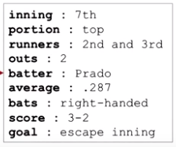

* + Put this into working memory.
* The contents of the working memory invoke different kinds of knowledge from the long term memory. The procedural knowledge is presented as rules, known as a production rules.
* Example:

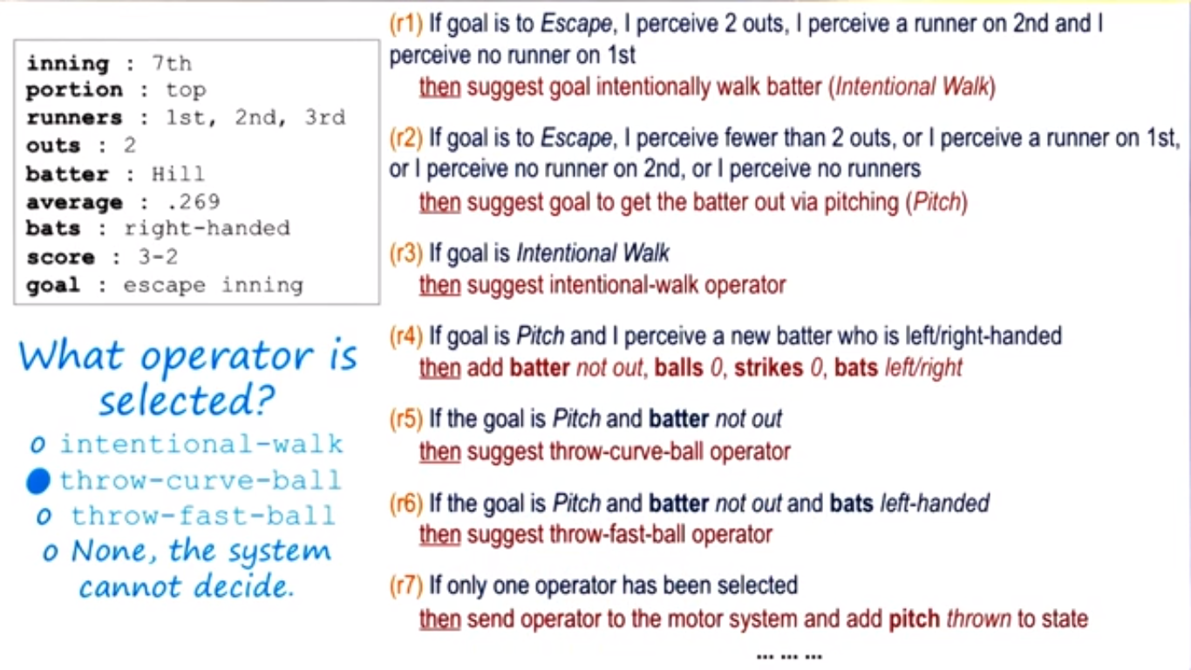

* If-statement usually consist of goals and/or percepts, then consists of suggesting another goal or performing some action.
  + Rules are often labelled (e.g. r1, r2).
  + One rule often fires off another rule.
* Knowledge is very detailed for production systems.

Chunking

* Sometimes, two operators may be selected.
  + (In above example, batting left-handed would result in r5 and r6 firing.)
* In SOAR theory, an impasse occurs when there is not enough knowledge available or because multiple courses of action are being selected and the agent cannot decide among them.
* SOAR will attempt to learn a rule that might break the impasse, invoking episodic knowledge (i.e. prior events). It tries to find past events that are similar to the current state and add a new rule based on that.
  + This process of using episodic knowledge to break the impasse is called chunking.

Fundamentals of Learning

* Knowledge Based AI starts with the theory of reasoning (answering questions like what to learn, when to learn, why do learning) and then asks how to learn.
  + This happens in production systems: when an impasse is reached, then it chooses to resolve the impasse from episodic memory.

Production System in Raven’s Progressive Matrices

* The agent has a set of rules of what to look for, applying it to rows and columns, and it knows how to reply to those things.

The Cognitive Connection

* Production systems are proposed as models of human cognition.
* The working memory in production systems is similar to the short-term memory of human cognition.
* There are strong similarities between programs like SOAR and the behavior of humans when they address arithmetic and algebra problems.

**Frames**

Preview

* Frames enables us to do common sense reasoning. Ex: if you ate a frog, it’s probably dead.

Example of Frames

* We can build frames around the verb of a sentence
* A frame consists of slots (keys); each slot has a corresponding filler (value). Some fillers are filled in by default, others from parsing the sentence.
* In the example below, there are two frames built around the word “ate”. Hence, the slots are the same.
  + object-alive, object-is, and subject-mood are filled with default values.

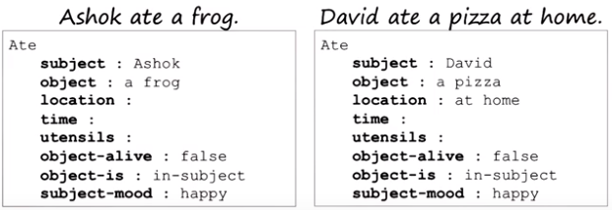

* A frame is a knowledge structure (more complicated than a single knowledge representation). Can expand, can contract; you can do a lot more with frames.

Complex Frame Systems

* You might have a frame point to another frame in one of the frame’s filler.
* Example:

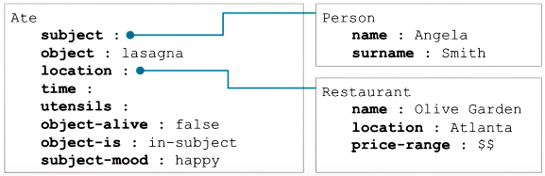

* The ability to hook these frames together allows for a lot of complex inferences and becomes a major part of common sense reasoning.
* These examples are sentence-level understanding. Discourse level understanding is when there is a series of sentences being understood.

Properties of Frames

* Frames:
  + Represent stereotypes: the slots represent a stereotypical notion of what happens when someone is eating something
  + Provide default values: but you can have exception to default values (e.g. if you don’t like frogs and ate one, you become sad instead of happy). Exceptions are powerful, but a problem in terms of handling those exceptions. Think of default values as a constructor in OOP.
  + Exhibit inheritance (e.g. an ant is a subclass of animal). You inherit slots from the superclass (and may have additional slots)

Frames and Semantic Nets

* Frames can be used for the Raven’s Problem. Example:

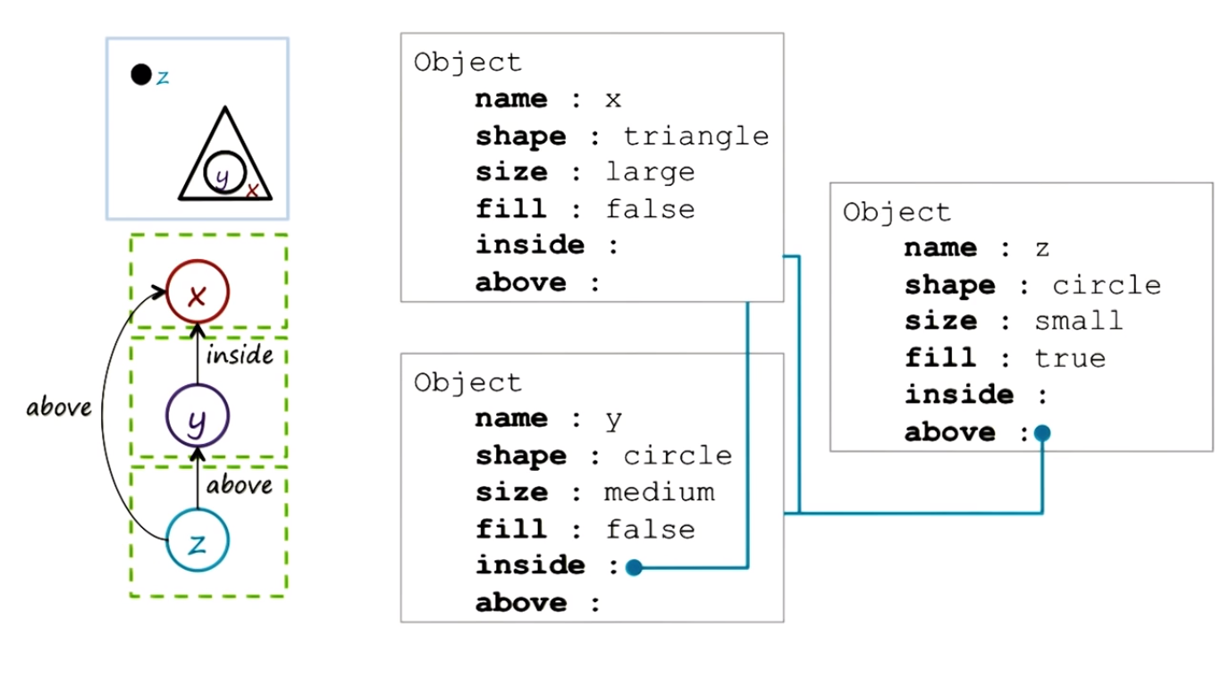

* + Instead of drawing arrows, we can just use the object’s name.
* Notice the similarity between frames and the semantic networks.

Frames and Production Systems

* The working memory used in the production system is similar to a frame.

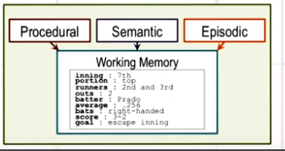

* Frames essentially captures conceptual knowledge that is stored in the semantic memory.
  + Upon seeing a sentence, it goes into the semantic memory, finds the corresponding frame, adds relevant slots and default values.
* A combination of top-down and bottom-up processing: top-down to find the correct frame and find what slots to look for, then bottom-up processing to figure out what values to put in the slots.
* Limitation of frames: sentences have lots of nuanced meanings: small changes with big difference in meanings that frames can’t capture if not designed well.

The Cognitive Connection

* Frames are a structured knowledge representation. Frames (unlike production systems) can capture a large amount of information in organized manner as a packet
* Frames enable the construction of a theory of cognitive processing which is both bottom-up and partially top-down. The data results in the retrieval of information from memory, which then makes sense of the data.
* Frames capture the notion of stereotypes of various events and situations.
  + This is cognitively efficient: have default values to generate expectations very rapidly.

**Learning by Recording Cases**

Learning by Recording Cases

* The agent records several cases (problems and answers). Now when faced with a new problem, it retrieves the most similar case in memory to answer it.

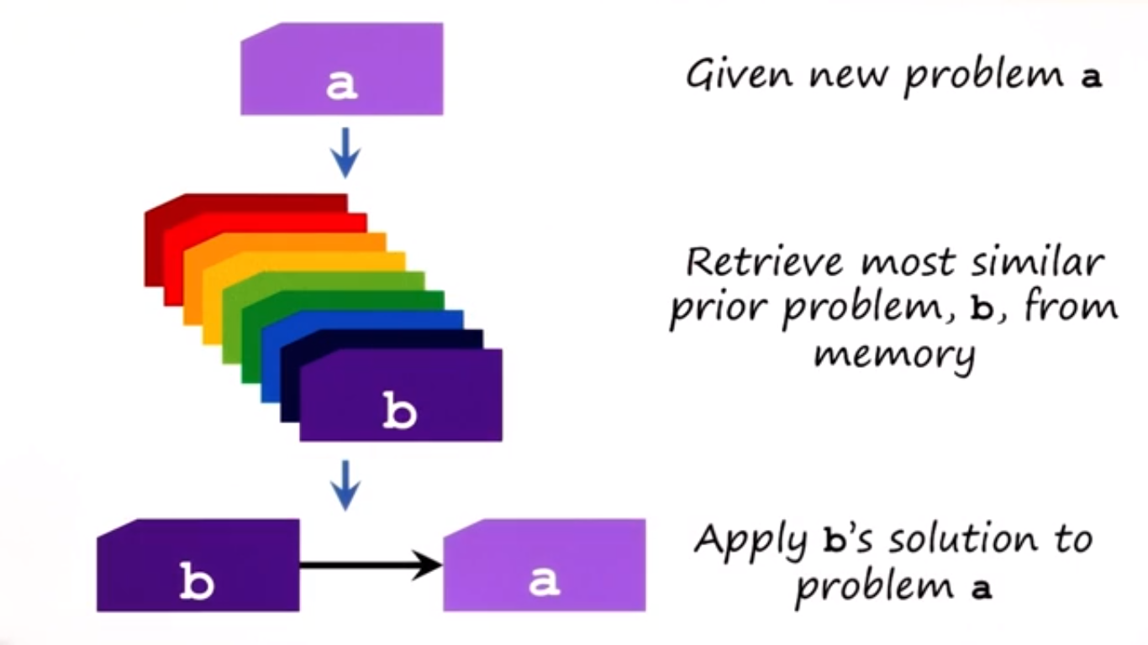

* Example: problem solving in programming. Think of past programming problem solving techniques, and apply the most suitable one to the current programming problem.
* A case is an encapsulation of a past experience.

Case Retrieval by Nearest Neighbor

* The nearest neighbor involves a function that quantifies the difference between the new problem and each of the prior experiences. Let “b” be the problem with the smallest difference. Apply b’s solution to problem a.
* Nearest neighbor function often is the Euclidean distance function. For each prior problem:
  + For each dimension, take the square of the difference between the new problem’s dimension value and the prior problem’s dimension value. Add the values up and square root it.
* For example, find the closest route to a list of 6 possible route choices.
  + For each route, let the difference between that route and the new route be equal to the square root of the sum of the distance between the origins and the distance between the destinations.
* This is known as the KNN method (K-Nearest Neighbor method)
* Limitation: the number of dimensions in which one may want to compute the distance might be very large. Additionally, the most similar prior problem should not necessarily be directly applied to the new problem.
  + Case-based reasoning provides the alternative methods of retrieving cases from memory and adapting similar cases to fit the requirements of the new problem.

The Cognitive Connection

* We use learning by recording cases because the same problems occur again and again.
  + Shows that learning and memory (not just reasoning) is important for intelligence.

**Case-Based Reasoning**

Preview

* Problem: the new problem is often not identical to any of the prior problems.
  + We need to do some reasoning in such cases.
* The cognitive agent addresses new problems by tweaking solutions to similar previously encountered problems.
* Consists of two parts: case-based (refer to previous section on case-based reasoning) and reasoning (to adapt prior problems)

Recording Cases to Case-Based Reasoning

* Case-Based Reasoning consists of the following steps in order:
  + Retrieval: retrieving a case from memory similar to the current problem
  + Adaptation: adapting the solution to that case to fit the current problem
  + Evaluation: evaluating how well the adapted solution addresses the current problem. If evaluation succeeds, then move to next step.
  + Storage: storing the new problem and solution as a case
* This case-based reasoning unifies memory, reasoning, and learning.

Assumptions of Case-Based Reasoning

* Case-Based Reasoning assumes:
  + Patterns exist in the world
  + Similar problems have similar solutions
* These assumptions are true most of the time, but of course are not always true.

Case Adaptation

* Case-based reasoning is a solution to tackle the conundrum that problems AI agents face are complex, but they have limited computational resources.
* We retrieve a memory that is almost identical to the current problem, and perform some minor tweaks.
* Three important ways to adapt a previous similar solution to fit the current problem: model-based method, the recursive case-based method, and the rule-based method.

Case Adaptation by Model of the World

* You use a model to adapt similar prior problems to your new problem.
* Example: You want to go from Point A to Point B. You know how to get from Point A to Point C, which is very close to Point B. You then can adapt the route from Point A to Point C by appending the route needed to go from Point C to Point B by searching for such a route in the model.

Case Adaptation by Recursive Reasoning

* You retrieve a case that provides a partial solution to a problem. You then get a new problem, from which you retrieve a new case to partially solve the remaining problem. Repeat till you solve the whole problem.
* Ex: You want to go from Point A to Point C. You know how to go from Point A to Point B. You apply this case and are now left with Point B to Point C. You know how to go from Point B to Point C, so apply that to solve the original problem.
* A compound analogy is a specific type of adaptation by recursive reasoning.

Case Adaptation by Rules

* This method uses heuristics expressed in the form of rules.
  + A heuristic is a general rule of thumb – something generally but not always or completely true/accurate.
* Example: You want to go from Point B to Point A, and you know how to go from Point A to Point B. A heuristic that says that to go back from where you came, you just need to flip the directions.
* Example: if you want a product to be lighter, use a different material.

Case Evaluation

* Simulation is one way to evaluate a case-based solution.
  + Or do an execution in the world (physically try it).
* Sometimes execution is expensive, so simulation may need to be done before execution.
* Another way to evaluate a design is to share it with other designers and let them critique it.

Case Storage

* After a successful evaluation of a design, store it in memory so that it could be later used as a case for a future problem.
* Case storage is an important way of learning.
* There are two main storage mechanisms: indexing and discrimination trees

Case Storage by Index

* Index each case based on a certain dimension.
  + Example: to index several routes, you could index each route by its starting location -- (x, y) coordinate. Can also index by whether the route is scenic, is fast, etc.
* We want an indexing structure such that when we have a new case, we have an effective and efficient way to retrieve similar cases.
* As the number of cases increases and/or the number of dimensions stored increases, storage becomes more inefficient. Discrimination trees provides an alternative way of storing cases in memory.

Case Storage by Discrimination Tree

* A discrimination tree is a knowledge structure in which the cases are the leaf nodes of the tree and parent nodes are questions.
* Example:

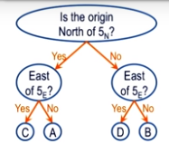

* To add a new case, you would first add the case as a leaf node down the correct path. But this will result in two cases having the same tree path, so you would need to add a new question node to differentiate the two cases.
* The discrimination tree becomes a modified discrimination tree when you add a new case (with a new question).
* An example of incremental learning.
* Discrimination trees don’t have to be binary. Can have question with more than 2 possible responses.
* Discrimination trees reduce lookup time to be O(log(n)) instead of O(n) for case storage by index.

Case Retrieval Revisited

* After storing cases using a discrimination tree, retrieving an existing case (or similar case to the new problem) is just as simple as finding a node in the tree.
* Retrieval by index involves pairing each case against the new problem.

Advanced Case-Based Reasoning

* The Case-Based Reasoning Process (Retrieval -> Adaptation -> Evaluation -> Storage) is not necessarily linear.
  + If the evaluation found that the solution failed, then you could try try adapting that case again, or you could try retrieving a different case.
  + If the retrieved solution could not be adapted, retrieve a different solution.
  + If the retrieved case perfectly matches the current problem, no adaptation is needed.
* Sometime studying failed cases is very useful, so you may want to still store those cases. May be helpful for anticipating problems for new cases.
* It may not be useful to store every successful case: case memory would become very large and retrieval would be inefficient – this is called the utility problem.
  + Only store successful cases that store a larger span of problems.

The Cognitive Connection

* Case-based reasoning has a strong connection with human cognition.
* Analogical reasoning is considered to be a core process of cognition.
  + Occurs on a spectrum of similarity (between new problem and old problems)
  + In the middle of this spectrum, we need to tweak past solutions to past problems that are similar but slightly different from the new problem.
* Learning by recording cases focused on learning and memory instead of reasoning in the cognitive architecture. Cased-based reasoning unifies all 3 by adding reasoning to adapt previous solutions.

**Incremental Concept Learning**

Preview

* Goal of extracting concepts out of examples stored by case-based reasoning
* Characteristics of Concept Learning
  + Learning is often incremental (e.g. learning from one example at a time).
  + Examples are often labelled (e.g. object A is a “foo” but object B is not a “foo”). This is called supervised learning in ML literature.
  + Examples can come in a particular order (e.g. first example is a positive example)
  + This is different than case-based reasoning, which stores raw examples into memory. For this, we extract abstract concepts from them.
  + The number of examples from which we’re extracting concepts may be small.
  + Finding the right level of generalization is a hard question. Abstracting concepts runs into the problem of what to abstract/generalize, what to learn? Tendency to overgeneralize or overspecialize.

Incremental Concept Learning

* Algorithm of concept learning:

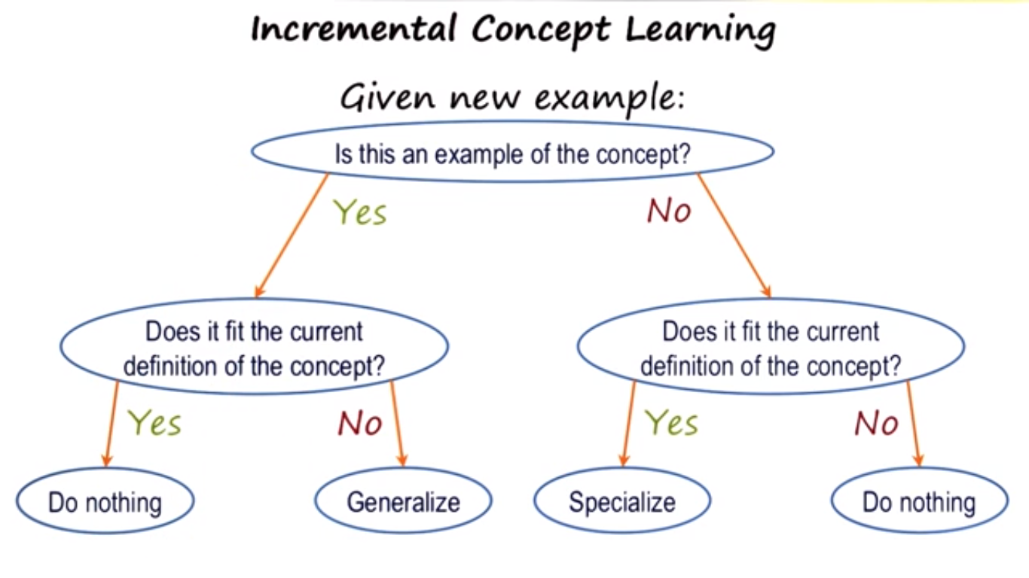

Variabilization

* Variabilization is the process of replacing each instance of an object in an example with a variable. Example (defining what an arch is):

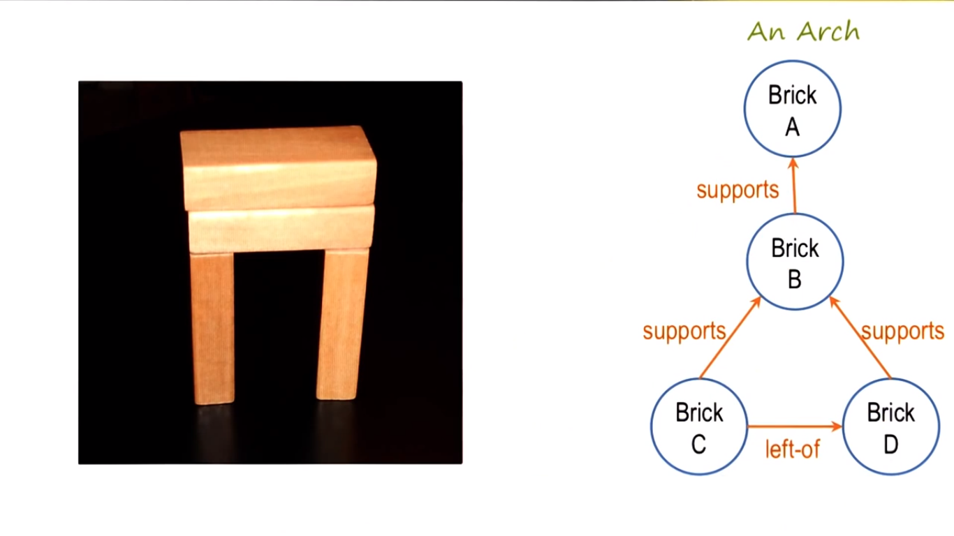 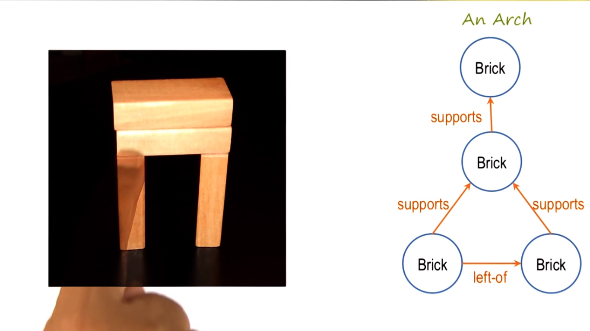

Generalization to Ignore Features

* Generalization occurs if a new positive example is given but the current definition does not fit the example. If so, a new (more general) definition is needed to fit the new example.
* Example of generalization:

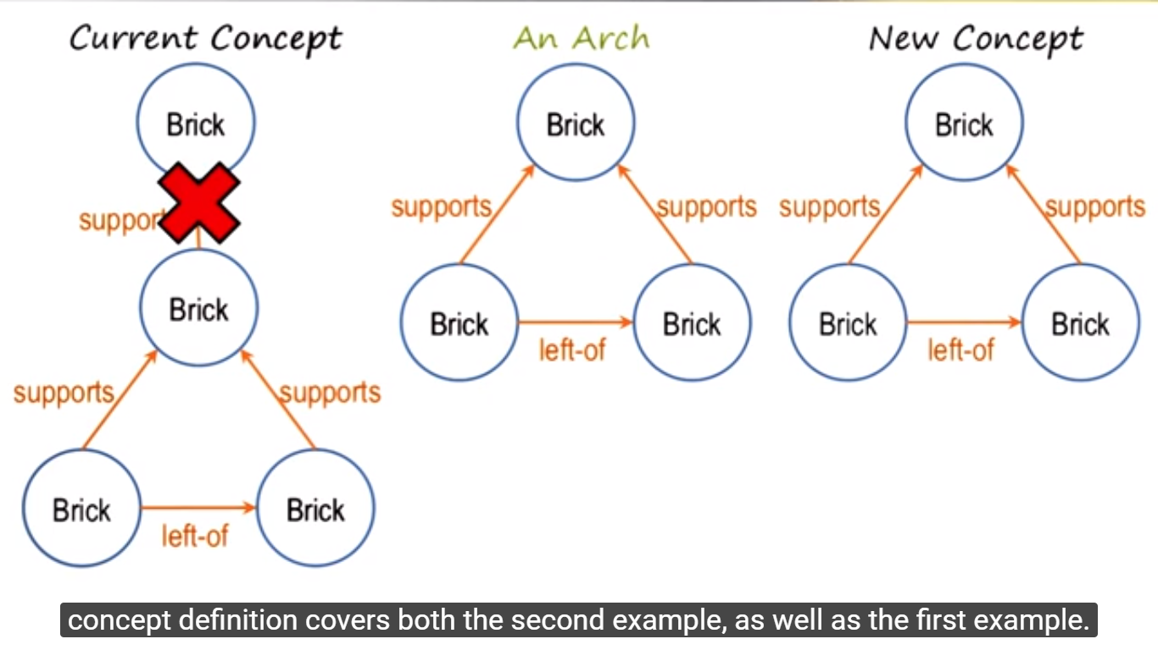

* The above example uses the “drop-link heuristic”. Dropping a link (and maybe a node) would make the definition more generalized.
  + The “drop-link heuristic” is helpful when there is a lot of overlap between the current concept and the new example.
* The learning space is large when there are only a few examples, so heuristics are helpful to help guide the AI agent.

Specialization to Require Features

* Specialization occurs if a new negative example is given but the current definition does fit the example. If so, a new (more specific) definition is needed to fit the new example.
* Example:

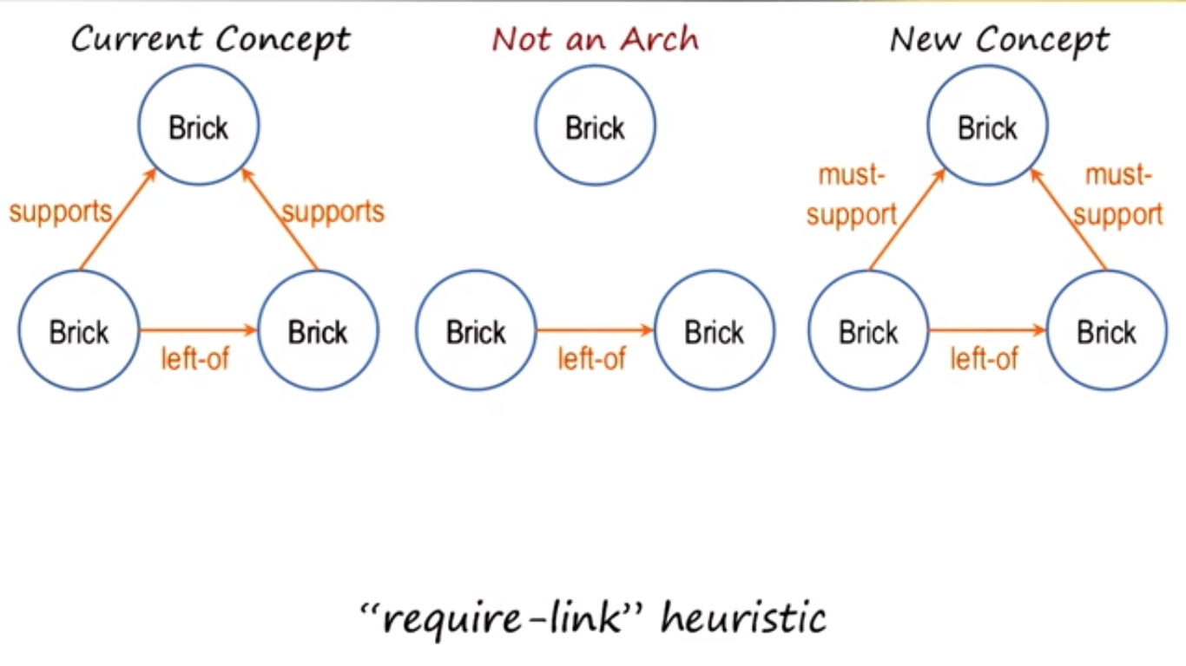

* The above example uses the “require-link” heuristic, making certain links required to fit the definition.

Specialization to Exclude Features

* An AI agent can also specialize its definition by requiring certain features to not occur.
* Example:

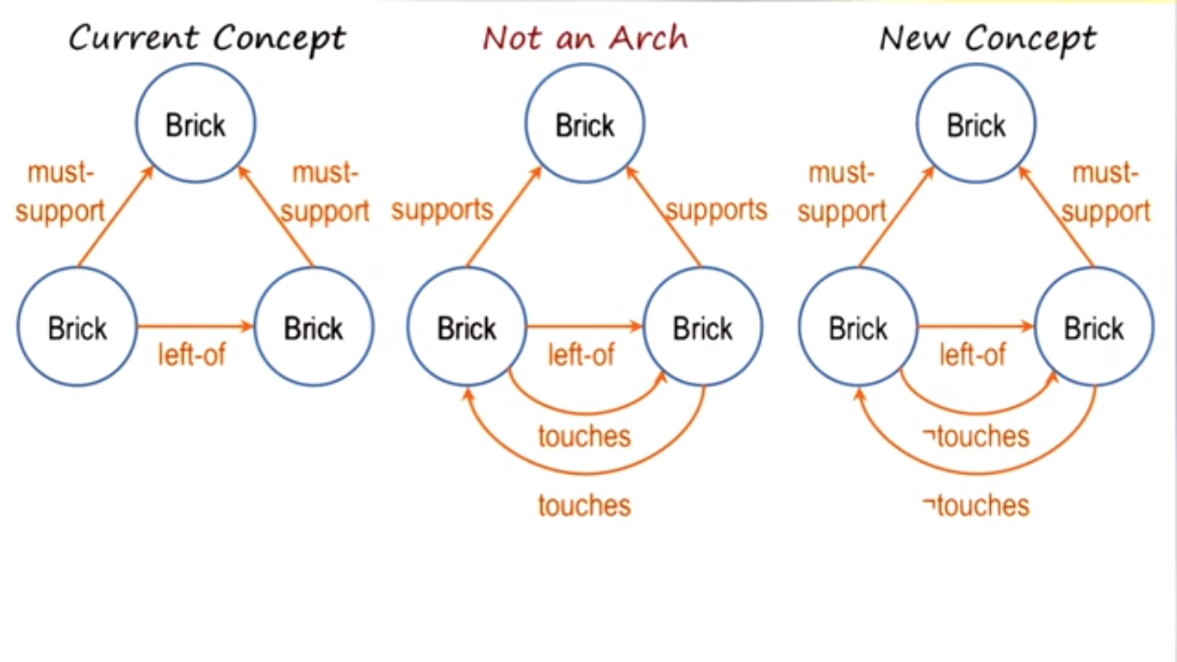

* + This is the “forbid-link” heuristic, certain links are forbidden to exist in the definition.

Generalization to Abstract Features

* Another way to generalize the definition is to provide several options for each object or relationship.
* Example:

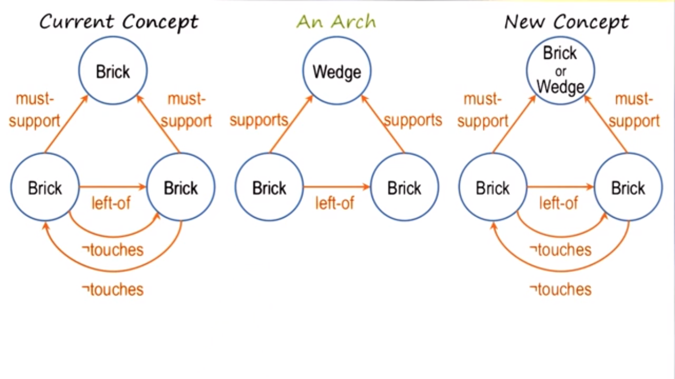

* + This is the “enlarge-set” heuristic: enlarging the set of a particular node.

Generalization with Background Knowledge

* An AI agent may have background knowledge that could simplify enlarged sets.
* Example:

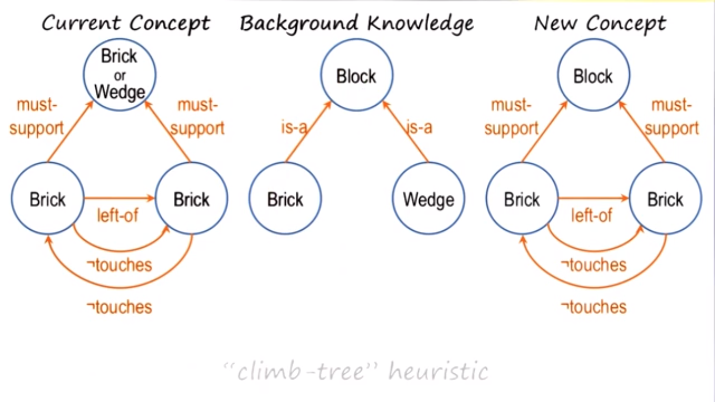

* + This is the “climb-tree” heuristic. (Background knowledge looks like a tree, and we’re “climbing” the knowledge.)
  + Note: if the AI knew that a cylinder was a block, then this generalization would allow cylinders to also be included in this definition.

Other Info

* With a small set of positive and negative examples, the number of dimensions that the algorithm can generalize and specialize is large. We can constrain the learning in this complex learning space by using the heuristics mentioned above and background knowledge.
* The final definition of a concept depends on the background knowledge that the AI agent has.
* This differs from ML, in that ML has lots of examples and hence can do math/statistics. This algorithm works better for a smaller number of examples, and those examples can come one at a time (learning incrementally).

Close-Interval Heuristic

* Ex: Your definition of dogs is only small dogs. A large dog comes and you are told it is also a dog. Hence you expand the range of how large a dog can be in your definition.

Recap: Heuristics for Concept Learning

* Require-link: link must be present to be a positive example of the concept
* Forbid-link: link must be absent to be a positive example of the concept
* Drop-link: link is not necessary to be a positive example of the concept
* Enlarge-set: multiple objects or links may fit one role in the concept
* Climb-tree: generalize over multiple objects in the same role based on knowledge
* Close-interval: expand range of values to be a positive example of the concept

The Cognitive Connection

* Incremental concept learning is intimately connected with human cognition.
* The agent is given one example at a time, similar to how we perceive things at one at a time usually.

**Classification**

Preview

* Classification is mapping sets of percepts in the world into equivalence classes so that we can take actions in the world in an efficient manner.

The Challenge of Classification

* Recall that the cognitive system maps percepts to actions.
* If there are “n” categories of percepts (e.g. “has wings” “has feature”) and “m” categories of actions (e.g. “pet” or “run away”), then there are $2^{n}$ combinations of percepts to map to $2^{m}$ combinations of categories (assuming each category is binary).
  + This is a very complex mapping!
* In the real world, we are constantly face a complex environment with a large number of percepts and a large number of combinations of actions possible.
* The question is how can an agent with limited resources efficiently maps percepts to the correct action at least most of the time in near real-time.

Equivalence Classes

* This is one possible solution to the main question (stated above).
* The $2^{n}$ percepts can be mapped to *k* concepts, each of which is an equivalence class for a large number of the combinations of percepts.
* Now you can index your actions on the equivalence classes (or concepts)
* This essentially maps the large number of percepts into a few concepts, and then map the few percepts to the possible actions. A lot more efficient and easier to understand.
* This is a very powerful topic studied often in AI.

Concept Hierarchies

* A concept hierarchy is basically several levels of subclasses/superclasses.
* Example: Animal has subclasses: vertebrate, invertebrate (each with their own subclasses). Vertebrate, for example, has reptile, birds, and mammals (each with their own subclasses). Birds, for example, has eagle, bluebird, penguin, etc.
* Benefit is the ability to go top-down (more general superclass to more specific subclass) to help identify a specific animal (for example).
  + Or if you identify a new species, then a concept hierarchy would help label it.
  + Going top-down results in an establish-refine loop: establish your species as satisfying the definition of the most general superclass. Now refine it to go one level down and establish it as satisfying a more specific class. Repeat till you get a child.
* There is organization of these different classes in a concept hierarchy.
* For concepts that have a “formal nature” (see below), we have the ability to look at each of the subclasses, and note any common characteristics all of them have; such common characteristics could instead be added into the superclass.

Types of Concepts

* Concepts lie on a spectral of less formal to more formal.
  + For more formal concepts, we can define logical conditions that are necessary and sufficient for that concept.
  + For less formal concepts, it is hard to define necessary and sufficient conditions.
* Axiomatic concepts are the most formal, prototype concepts less formal, and exemplar concepts are the least formal.
* Humans generally find it easier to communicate about axiomatic concepts because they are well defined; there is a set of necessary/sufficient conditions we all agree with.
  + Example: mathematical concepts
* It is easier to teach computers (or program onto computers) axiomatic concepts.

Axiomatic Concepts

* Axiomatic concepts are defined by a formal set of necessary and sufficient conditions
* Example: a circle (all points in a plane that are equidistance from a single point)

Prototype Concepts

* Prototype concepts are base concepts defined by some typical example with overridable properties.
  + Example: a chair. A chair usually has 4 legs, has a back, is not cushioned, etc. But that is not necessarily so – there are no necessary and sufficient conditions.
* Prototypical concepts can be expressed in the form of frames.
* Despite the fact that we can override certain properties of a prototype concept, we still can have a notion of the prototype concept.

Exemplar concepts

* Exemplar concepts are defined by implicit abstractions of instances, or examples, of the concept.
  + Don’t have typical conditions (let alone necessary/sufficient conditions)
  + Example: beauty, freedom
* Very difficult to define, and hence to communicate or teach to an AI program.

Order of Concepts

* There are even less formal concepts than exemplar concepts
  + Qualia concepts (usually discussed by philosophers) are the raw sensations that we may get from our sensors (e.g. bitterness)
* Depending on the type of concept we are dealing with, we may choose a different knowledge representation and a different inference method.

Bottom-Up Search

* Sometimes we can start at the bottom of a concept hierarchy, which would help describe the upper level nodes.
* Example:

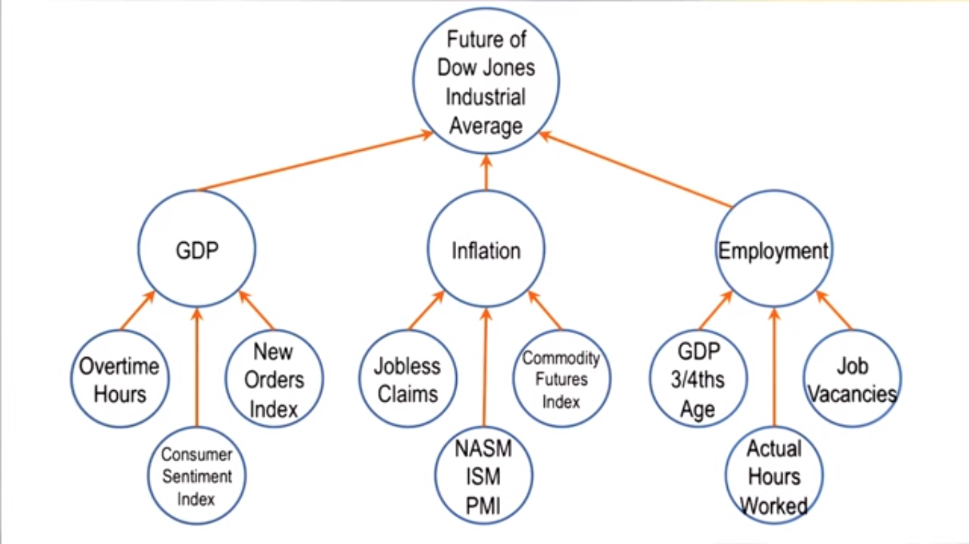

* + The AI agent can perceive the values of the leaf nodes (e.g. overtime hours), and from there, predict the future of the Down Jones Industrial Average
* As opposed to establish and refine for top-down, we can call this identify and abstract for bottom-up.

The Cognitive Connection

* There is a strong connection between classification and cognition.
  + Example: classify a particular car as a Porsche. Classify an erroneous computer output as a bug.
* Classification is so ubiquitous because it allows us to select actions efficiently.

**Logic**

Preview

* Logic is a formal language that allows us to make assertions about the world in a precise way.
* Formal logic would make the AI agent have two parts:
  + A knowledge base: the agent’s knowledge of the world. Expressed in the form of sentences in the language of logic.
  + Inference engine: apply rules of inference to the knowledge that the agent has.
* We may want the AI agent to show/prove that the answers it derives to any problem are correct. Or want the AI agent to generate only provably correct solutions.’
  + To guarantee this, we need a complete and correct knowledge base, and we need rules of inference that will give guarantees of correctness of answers.
* Inference has two parts to it:
  + Soundness: only valid conclusions can be proven -- the rules of inference will derive only valid conclusions
  + Completeness: all valid conclusions can be proven -- AI agent will derive all of the valid conclusions.

Predicates

* A predicate is a function that maps object arguments to true or false values.
  + Example (feathers is the predicate): feathers(bluebird)
* Can use if-statements to construct logic with predicates. Example (if the animal has feathers, then the animal is a bird):

If Feathers(animal):

Then Bird(animal)

* + This is an “implicative relationship”. “Features(animal) implies Bird(animal)”

Conjunctions and Disjunctions

* Use the conjunction to indicate an “and” relationship. Symbol: Λ
* Example: if an animal lays eggs and it flies, then it is a bird:

If Lays-eggs(animal) Λ Flies(animal):

Then Bird(animal)

* Use the disjunction to indicate an “or” relationship. Symbol: ν
* Example: if an animal lays eggs or it flies, then it is a bird:

If Lays-eggs(animal) ν Flies(animal):

Then Bird(animal)

* Use the not operator to indicate a “not” relationship. Symbol: ¬
* Example: if an animal flies and is not a bird, then it is a bat:

If Flies(animal) Λ ¬Bird(animal):

Then Bat(animal)

Implies

* Use arrow-symbol for implication (above example use semicolon, but this is more correct): ⇒
* Example:

If Lays-eggs(animal) Λ Flies(animal):

Then Bird(animal)

Becomes:

Lays-eggs(animal) Λ Flies(animal) ⇒ Bird(animal)

* The left side implies the right side.

Truth Tables, Commutative Property for And and Or, Distributive Property, Associative Property for AND and OR, De Morgan’s Law

* (Google these concepts if not familiar)
* Distributive Property: A Λ (B ν C) == (A Λ B) ν (A Λ C)
* We can rewrite the sentences found in the agent’s knowledge base using these properties

Truth Table of Implications

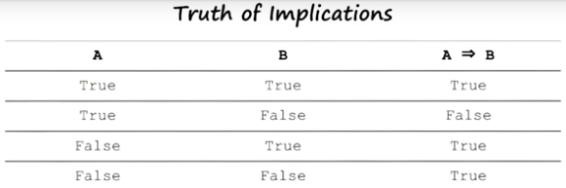

* If an animal has feathers, it is a bird is a true implication (row 1)
* If an animal has scales, it is a bird is a false implication (row 2)
* If an animal does not fly, it can be a bird is a true implication (row 3). Ex: penguin
* If an animal does not fly, it could not be a bird is a true implication (row 4). Ex: cat

Implication Elimination

* Given: a ⇒ b, we can rewrite it as: ¬a ν b

Rules of Inference

* Rules of inference: instantiate general rules to prove specific claims
* Modus Ponens:

Sentence 1: p ⇒ q (p implies q)

Sentence 2: p (p is true)

∴Sentence 3: q (therefore, q is true)

* Modus Tollens (contrapositive):

Sentence 1: p ⇒ q (p implies q)

Sentence 2: ¬q (q is not true)

∴Sentence 3: ¬p (therefore, p is not true)

* Sentence 1 usually comes from knowledge that is bootstrapped to the AI agent, sentence 2 usually comes from percepts, and sentence 3 comes from the logical inference.
* Two main ways of proving the truth value of sentences: through truth tables, and through applying rules of inferences (e.g. modus ponens)
* But truth tables and modus ponens become very complex as the size of the background knowledge increases. Not always computationally feasible.

Universal Quantifiers

* Propositional logic (aka zeroth-order logic): logic without variables.
  + Example: Lays-eggs(animal) Λ Flies(animal) ⇒ Bird(animal)
  + This logic only applies for one animal, and would need to be written for each animal (i.e. animal 1, animal 2, etc.)
* Predicate calculus uses variables and the quantifiers to apply logic for more than just one value.
* Universal quantifier to apply to all animals:
  + ∀x[Lays-eggs(x) Λ Flies(x) ⇒ Bird(x)]
  + The universal quantifier (∀) is needed to indicate “x” can take on any value.
  + This statement written as-is applies to all values the variable can take.
* Existential quantifier to apply to at least one animal:
  + ∃y[Lays-eggs(y) Λ Flies(y) ⇒ Bird(y)]
  + This sentence is necessarily true for all values of y, but it is true for at least one value of y.

Resolution Theorem Proving

* Resolution Theorem Proving: convert each sentence into a conjunctive normal form, and then use proof by refutation.
  + A conjunctive normal form can have one of three conditions: can be a literal (i.e. positive item or negative item), have disjunctional literals, or can have a conjunction of disjunctional literals.
  + Then take the negation of what we want to prove, assuming it.
  + Find the negation of what we assumed in the previous system in a previous sentence. Then eliminate both the assumption and the matching negation of the assumption (this is called resolution).
  + Repeat the procedure until we reach the null condition (no conditions remaining), which is a contradiction, and hence proof by contradiction.
* Example: Let’s say we know (S1) ¬can-move ⇒ ¬liftable, and we find (S2) ¬can-move. Use Resolution Theorem Proving to prove ¬liftable.
  + Rewrite S1 to make it into a conjunctive normal form: can-move ν ¬liftable
  + S2 is already in a conjunctive normal form, so leave it as is.
  + We take the negation of what we want to prove; we assume: (S3) liftable.
  + We then find the negation of what we assumed (¬liftable) in S1. This gives us S1: can-move and nothing left in S3. S2 still is ¬can-move.
  + We can try to resolve S1 with something; S2 contains the negation of S1. Hence, we resolve S1 and S2, leaving nothing left in any of the sentences.
* Even though it may not look like so, Resolution Theorem Proving is often computationally easier than Modus Ponens
  + It is easier to figure out what to focus on in Resolution Theorem Proving, unlike Modus Ponens.
  + This efficiency of Resolution Theorem Proving comes out of “horn clauses”, which is a disjunction that contains at most one positive literal. This one positive literal is where the focus of attention comes from.

Another Example of Resolution Theorem Proving

* We know: (S1) ¬can-move Λ battery-full ⇒ ¬liftable. We find: (S2) ¬can-move, (S3) battery-full. How do we prove the box is not liftable?
* Rewrite S1: ¬(¬can-move Λ battery-full) ν ¬liftable. But this is a disjunction of conjunctions, so use De Morgan’s law to get conjunctions of disjunctions: can-move ν ¬battery-full ν ¬liftable.
* We assume the negation of what we want to prove: (S4) liftable
* We resolve liftable in S4 and ¬liftable in S1, crossing them out. S1 now reads: can-move ν ¬battery-full. We then continue with either of the literals in S1.
* Let’s pick ¬battery-full in S1. Resolve it will battery-full in S3. Now S1 reads: can-move, and S3 has no condition.
* Resolve can-move in S1 with ¬can-move in S2. Now we have the null condition (all 4 sentences without conditions), and hence a contradiction. Therefore, the assumption that liftable is true cannot be true, and so it is not liftable.

The Cognitive Connection

* Logic is an important topic in AI because:
  + Logic provides a very formal and precise way of reasoning
  + Logic provides a formal notation for expressing how intelligent agents reason
* Humans do use logic sometimes, but sometimes without using logic as the fundamental reasoning strategy
* We used deductive logic, but human reasoning is often inductive/abductive.
  + Deductive logic is reasoning from causes to effects.
  + Abductive logic is reasoning from effects to causes. Ex: doctor observes your symptoms (the effects) and infers the disease (the cause)
  + Inductive logic is, given some relationship between cause and effect for a sample, how to generalize it to be a cause and effect relationship for the population

**Planning**

Preview

* Planning is a powerful method for action selection.

States

* Use predicates (in the form of propositional logic) to describe states.
  + Example: On(Robot, Floor) Λ Dry(Ladder) Λ Dry(Ceiling) could be used to describe that the robot is on the floor, the ladder is dry, and the ceiling is dry.

Operators

* Specify operators using a set of preconditions and postconditions (both of which are states)
  + The operator can only be applied if and only if the preconditions are true in the world.
  + By convention, preconditions has no negative literals. (Ex: say that the ceiling is dry instead of not painted) Postconditions may have negative literals.

Planning and State Spaces

* Imagine planning be a graph of states linked by operations. If your planning algorithm does Breadth-First Search (i.e. expands each node with all possible operations), it can get computationally expensive very fast.
  + Use knowledge of the goal to help you decide what operations to perform. Generally, you want to perform operations that take you closer to the goal.’
* There is knowledge of the states and operators on one hand. There is another knowledge called control knowledge that tells you how to select which operator at each state. Goals provide control knowledge.
* A plan consists of the initial state, followed by the first action, followed by the resulting state, followed by the next action, followed by the next state, and so on till the goal state.
  + The preconditions of each operator matches its previous state, and the postconditions of each operator matches its next state.
* Recall that a problem with means-ends analysis is that its use of heuristics can sometimes get itself in trouble. This problem can be explained in terms of planning. The AI agent chooses action A to get closer to the goal. The AI agent then needs to perform action B to get closer to the goal, but the postcondition of action A does not satisfy the precondition of action B.
  + This is goal clobbering: means-ends analysis does not care about the order in which goals need to be satisfied.

Partial Order Planning

* Partial Order planning (aka non-linear planning) occurs when there are multiple goals, in which certain goals need to be achieved before others.
* Set the goal as the “control knowledge” that you will use to help select the operator, and work backwards.
  + Select operators whose post-conditions match the goal state. If it fits the current (initial) goal state, then that’s your plan.
  + If the operators whose post conditions matches the goal state does not have the necessary preconditions of the initial state, then repeat this process, setting this operator’s preconditions as a “subgoal”.
  + This “subgoal” strategy ties into the method of problem reduction.

Detecting Conflicts

* Imagine you had at least two goals to achieve and at least two plans to achieve those goals.
* For each precondition in current plan:

If precondition for an operator in the current plan is clobbered by a state in another plan:

Promote current plan’s goal above other plan’s goal.

* For example, if you have plan A and plan B, and if some state in plan B clobbers the application of an operator in plan A, then try accomplishing plan A before plan B.

Open Preconditions

* If Plan A is to be performed before Plan B, then an open precondition occurs when the post conditions of the final state of plan A does not satisfy the preconditions of the initial state of plan B.
  + If this happens, you need to find the set of operators that would link the postcondition of Plan A to the preconditions of Plan B.

Other Remarks

* Knowledge is not just about the world – there also is “control knowledge” or “tacit knowledge”, which helps us select between operators
* Goals provide control knowledge.
* We can view partial order planning as an interaction between several kinds of agents or abilities; each agent represents a small ability (e.g. Create a plan to achieve goal A, likewise for goal B, and link Plan A to Plan B)
* Society of Mind: each agent itself is very simple, but put together can create complex plans.
* We can solve these problems involving conflicts with ease; AI agents makes this process more explicit (and hence harder). This leads to hypotheses of how we reason.

Hierarchical Planning and Hierarchical Task Network

* For complex tasks, a complex plan may be required. We have a goal of abstracting away several operators at once into a “macro-operator”, or an operator that consists of many normal low-level operators. We can then expand the macro-operator into the normal operators.
* Example:

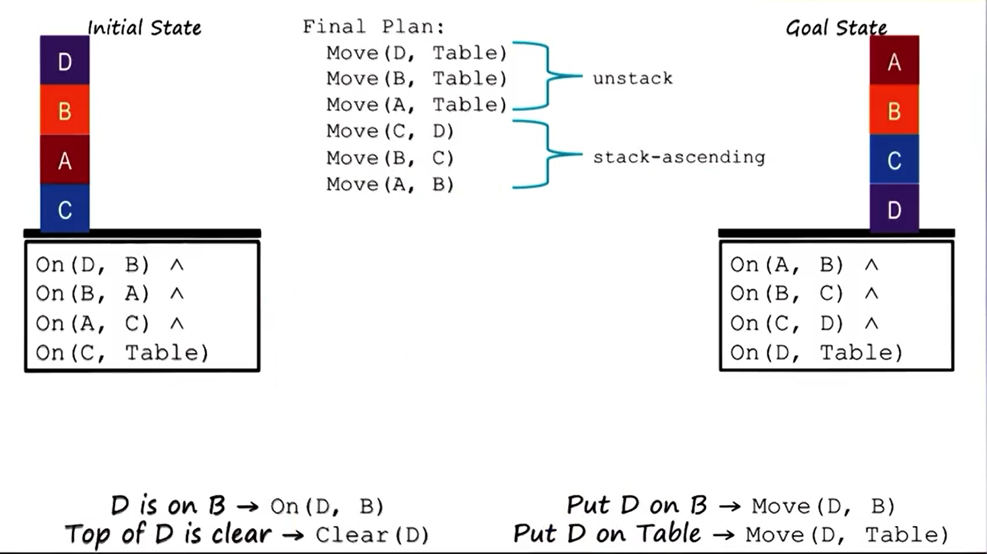

* + Where “unstack” and “stack-ascending” could be thought of as macro-operators.
* Macro-operators, like normal operators, have preconditions and post-conditions.
* We then can use the macro-operators for a simpler level of abstraction. Example (continued):

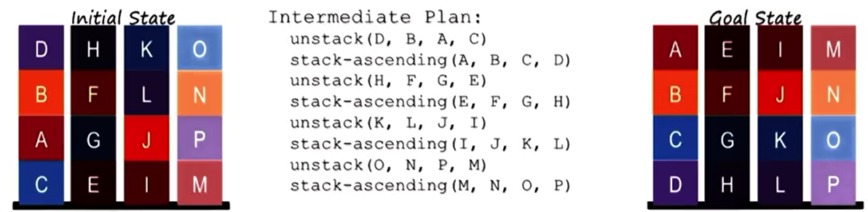

The Cognitive Connection

* Planning is central to cognition because action selection is central, and we need planning to select the appropriate actions.
* Cognitive agents also have multiple goals, which can have interactions between them.
  + Sometime the interaction is positive (achieving one goal helps achieve another)
  + Sometime the interaction is negative (i.e. they conflict). Cognitive agents detect those conflicts and avoid them, or work around them.

**Understanding**

Preview

* We will be talking about understanding in the context of story understanding.
* We encountered story understanding earlier using frames. One limitation of frames is that a word has multiple meanings; it is difficult to have the appropriate frame depending on which definition of the word is being used.
* To differentiate between different usages of a word, the AI agent needs a lot of background knowledge.

Example: “Ashok made pancakes for David with a griddle”

* How can we understand this sentence?
  + Lexical analysis: “Ashok” is a noun, “made” is a verb, etc.
  + Syntactical analysis: structure of the sentence. “Ashok” is a noun phrase. “made pancakes for David with a griddle” is a verb phrase, etc.
  + Semantic analysis: “Ashok” is the agent, “made” is the action, “pancakes” is the object being made, “David” is the beneficiary, “griddle” was the instrument.
* For KBAI agents, semantic analysis is the forefront; lexical analysis and syntactical analysis serve semantic analysis.
* We can check understanding of the meaning by asking you questions that force you to make inferences. Example: “Who ate the pancakes?”

Thematic Role Systems

* In order to resolve such ambiguities, we need a new knowledge representation called a traumatic rule system.
* A traumatic rule system is a type of frame system where the frame represents an action or event identified by a word.
  + The word calls for a number of expectations about the roles that are connected with that particular event.
  + Ex: the action of “throw” results in the expectations of something being thrown, someone throwing something, and possibly a target being thrown to/at.

Constraints

* The AI agent uses the structure of the sentence to make sense of that sentence.
  + The human language has a particular structure to it (e.g. prepositions)
  + Each preposition plays a thematic role (semantic categories), allowing us to draw inferences

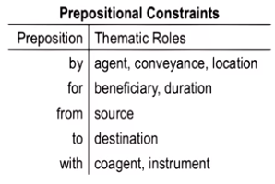

* The structure of language does provide constraints (e.g. above), but these constraints do not always determine the meaning of the particular word.

Resolving Ambiguity in Prepositions